Summon Overview: Introduction to Summon

1. Summon Overview: Introduction to Summon

1.1 Introduction to Summon
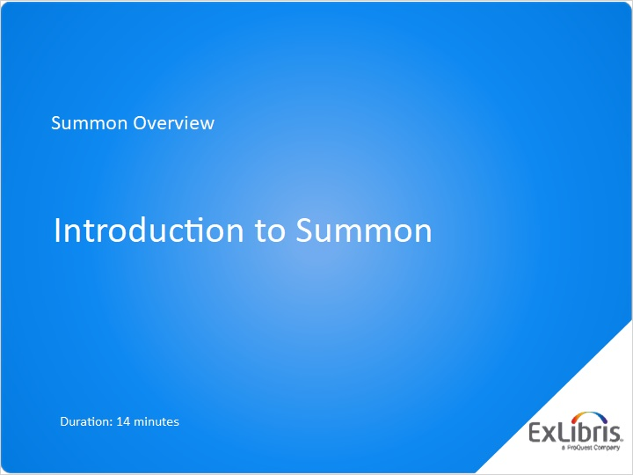
Notes:
Hello, and welcome to this “Introduction to Summon” training session.

1.2 What Summon Is
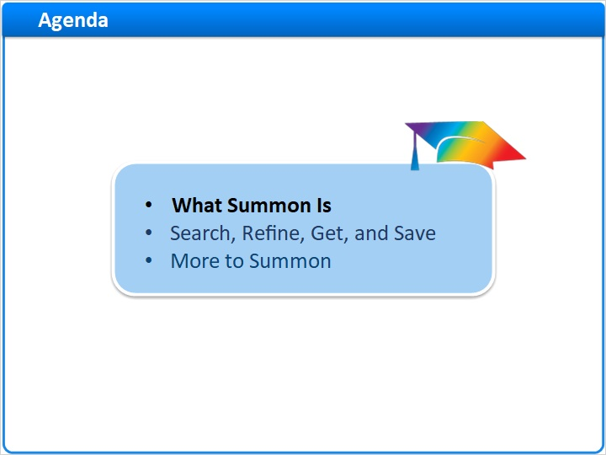
Notes:
By the end of this session, you’ll know what Summon is, how to use Summon’s basic features, and some other elements of the Summon interface.

We’ll start by considering what Summon is.

1.3 Summon Web-Scale Discovery
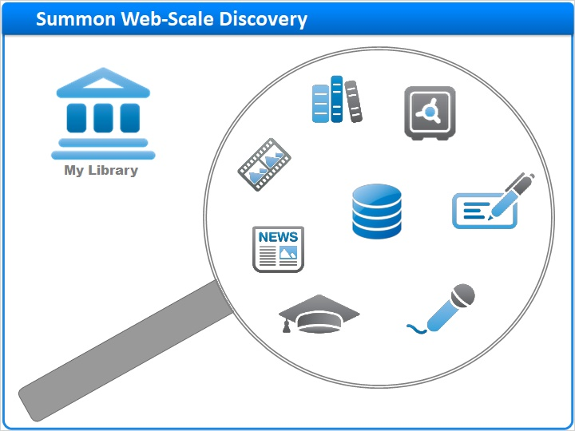
Notes:
The Summon Web-Scale Discovery Service uncovers content across the breadth of your library’s collections.

Depending on your library’s unique implementation, this can include everything from your library’s catalog to your full-text databases; from online video and audio, to your abstracting and indexing content. It can even include your library’s study guides and institutional repositories.

1.4 Ex Libris Central Discovery Index
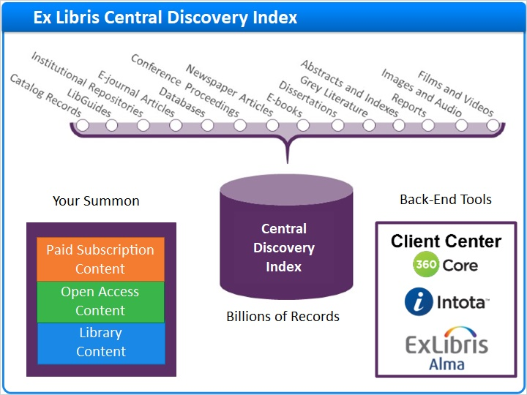
Notes:
Summon’s web-scale discovery capabilities are powered by the Ex Libris Central Discovery Index, which contains billions of records from more than 7000 content providers, including publishers, aggregators, professional societies, and institutions like yours. And, these records represent over 90 different content types.

With so much in the Central Discovery Index, you may be wondering, what’s in your Summon?

Your institution’s Summon implementation team will use one of three back-end tools -- the Client Center, Intota, or Alma -- to tell Summon which subscription and open-access e-resources to include.

Your institution may also work with Summon staff to have your own catalog, study guides, and institutional repositories added right into the Central Discovery Index.

All together, this allows researchers to discover content across your institution’s collections, using one, easy-to-use interface.

Cover for Content Types (Slide Layer)
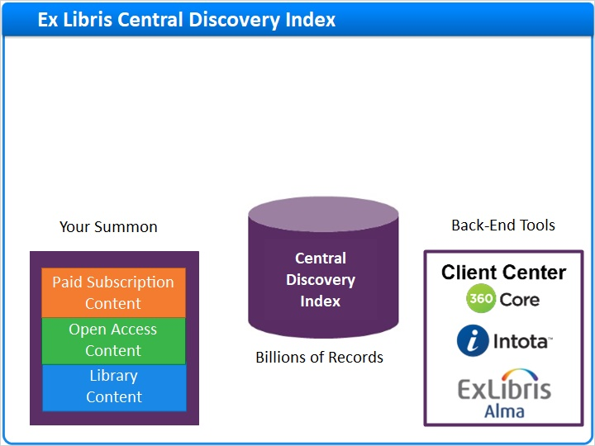

1.5 Summon Home Page
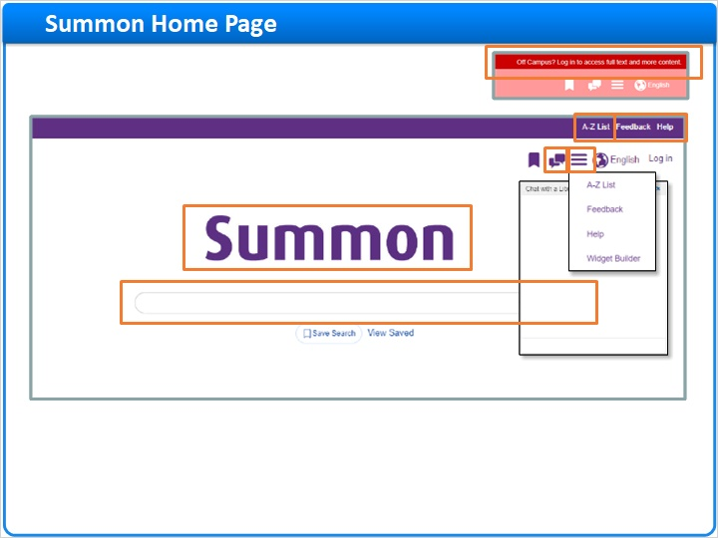
Notes:
Here is an example of a Summon Home Page. Your library’s Summon Home Page will look a bit different, depending on which features your library chooses to activate.

In the banner at the top of the page is a Help link, a Feedback link, and in some cases a custom link, such as this one for the library’s A-to-Z list. If your library supports remote access, unauthenticated researchers may see a login reminder instead of these links.

Click the icon to access the banner links, along with additional tools for building your own search widgets. Click back in the main page area to close the menu.

Your library’s Summon may also include an integrated chat widget that uses your library’s chat service.

Toward the center of the page, you’ll find your library’s logo, which your library will customize to show your branding or your custom name for Summon. Below the logo is the heart of Summon: one big search box for discovering content across your library’s diverse collections.

While we call this the Summon Home Page, most of your researchers will never see it. Instead, they’ll access Summon via a search box right on your library’s home page.

1.6 Summon Search Boxes
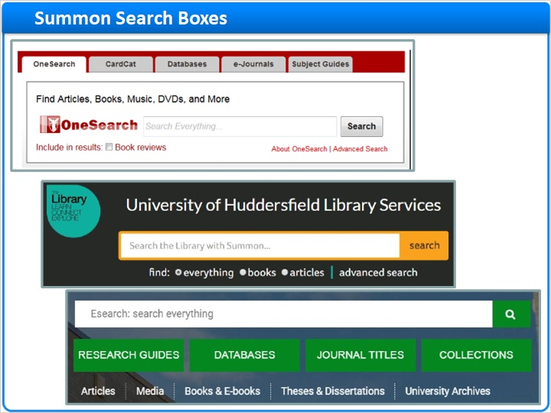
Notes:
Here are a few examples of Summon search boxes found on some library pages.

You’ll learn how easy it is to create your own search boxes in a separate training session.

1.7 Search, Refine, Get, and Save
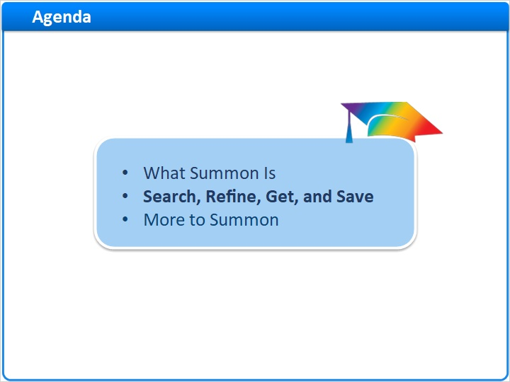
Notes:
Now let’s learn the basic steps for searching in Summon, refining our results, getting full text, and saving citations and searches.

1.8 Search Summon
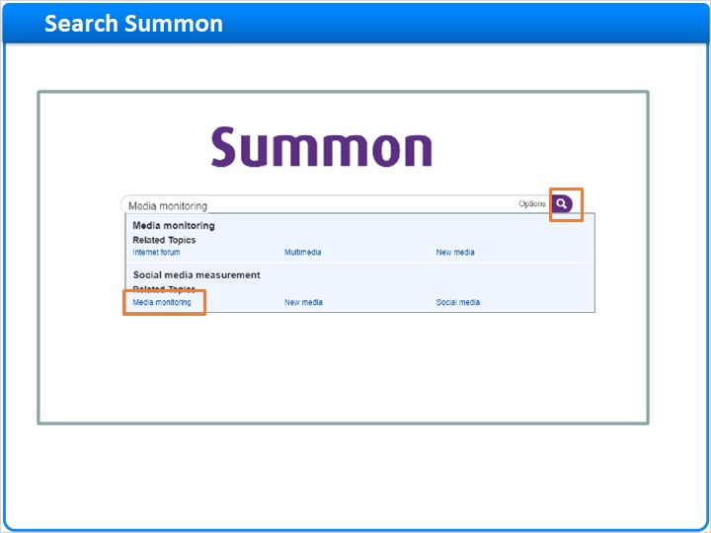
Notes:
We’ll start on the Summon Home page.

As I enter my search terms into the search box, the Summon autocomplete feature provides some suggestions. I could finish typing myself, but this time I’ll select the terms I want and click Enter or the Search icon.

In just seconds, Summon searches all the billions of records in the Central Discovery Index.

This search returned hundreds of thousand of results, sorted by relevance.

Summon uses a proprietary algorithm to determine how relevant each result is to the search terms. Results that are highly relevant are placed at the top of the search results, while less relevant results are placed farther down in the list.

It’s also possible to sort results based on date, but we don’t recommend this because sorting by date turns off relevance ranking. We’ll look at a better strategy -- filtering materials by publication date -- in a few minutes. Also, you can sort by Author or Title.

First, let’s look at our existing search results. As I scroll down the page, more and more results are automatically loaded. There’s no need to click to see the next page of results.

Among these results are journal articles, books and ebooks, reference materials, video recordings, study guides, and more.

If there happens to be a lot of newspaper coverage of my search terms, I’ll find that newspaper articles are grouped -- or “rolled up” -- together in my results. I can click here to see just newspaper articles.

And, if I don’t see what I want in my results, I can always enter a new search at the top of the page. I can change or add to my keywords, or click the X to clear all keywords and start over.

First Result Page (Slide Layer)
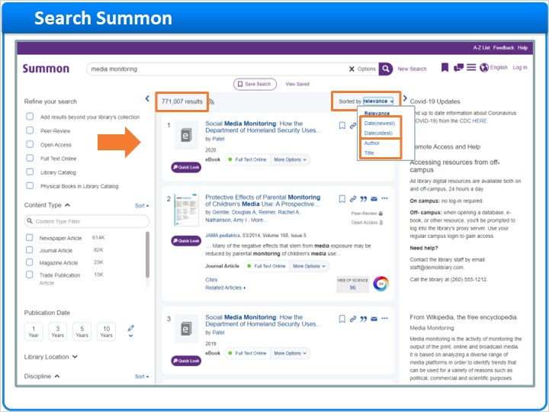

Scrolled results (Slide Layer)
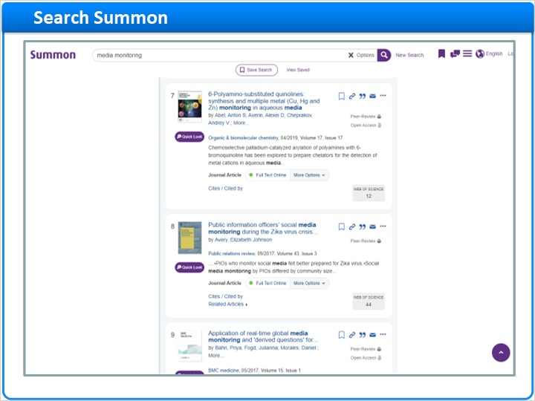

Result Varieties (Slide Layer)
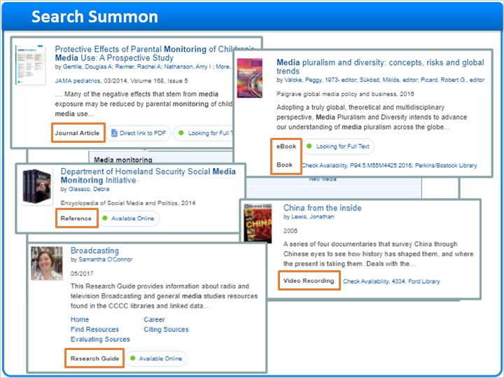

newspaper rollup (Slide Layer)
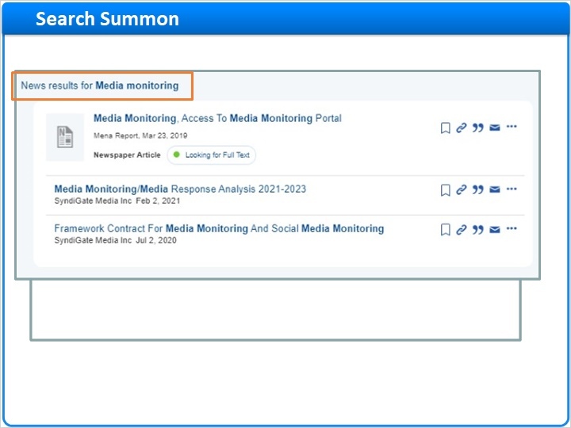

new search (Slide Layer)
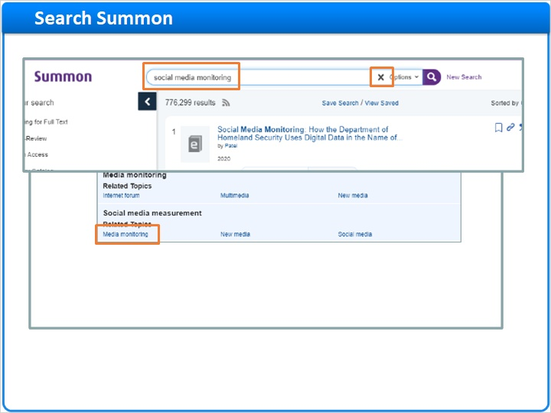

1.9 Refine Results
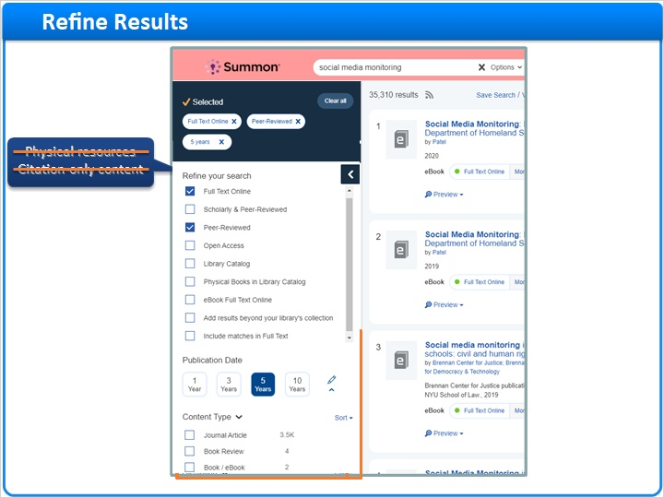
Notes:
When we have specific research requirements, we can use the refinements and facets on the left side of the screen to filter results by any given criteria.

For example, if I’m off campus, I may only be interested in the materials I can access online. I can select Full Text Online, and any physical resources and citation-only content will be removed from my results list.

Or, if I’m only interested in articles from peer-reviewed journals, I can select the Peer-Review refinement to eliminate articles that do not meet that criteria.

In addition to these refinements, I can filter on a variety of facets. In this case, I only want to see peer-reviewed articles from the last five years, so I select that button, which retains relevance ranking while finding recent content.

For other facets, like Content Type, I can click on any of the facet values that are displayed in the list, and thus only see results that have that content type. I scroll down to see more content types.

I want to eliminate book reviews from my results, so I'll hover over the Book Review content type and click Exclude.

My refinements and facet selections will remain in place between searches, but I can clear any of them individually by clicking the associated checkmark or on the facet-value name. Or, I can clear all selections by clicking the Clear Filters option. Also, if I click New Search, the refinements and facets and my search keywords are all cleared.

There are other facets further down on the left: Discipline, Subject Terms, and Language.

Some libraries choose to also provide facets for Author and Databases.

If this library used Alma, I could filter on Course Reserves content.

Context-specific facets are available if I limit my search to catalog records only. These are Library Location, Genre, Region, and Time Period.

Some facets start out expanded, while others are collapsed. I can click on a collapsed facet to display the facet values available for filtering.

Other facets (Slide Layer)
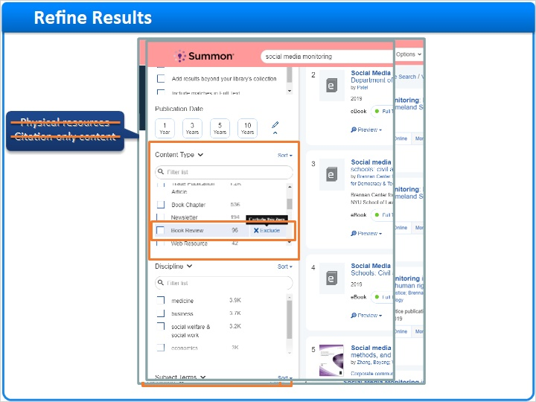

Clear Filters and New Search (Slide Layer)
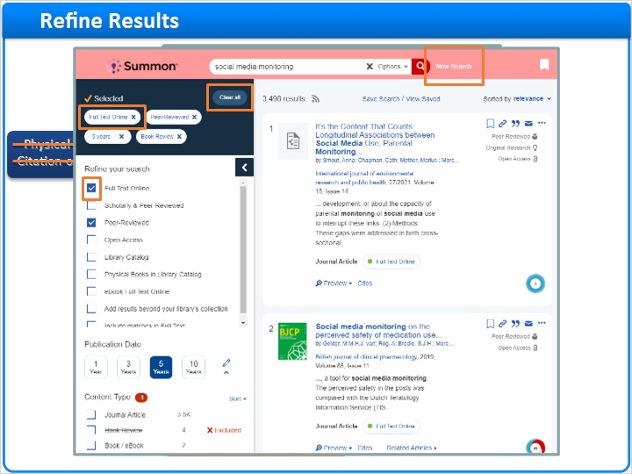

Still More Facets (Slide Layer)
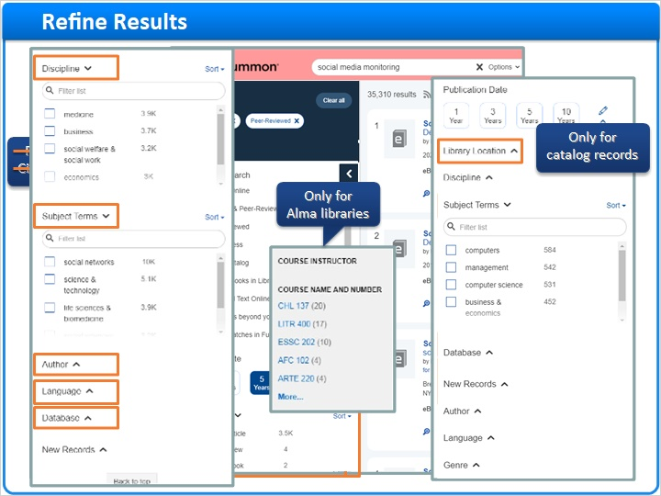

1.10 Get Full Text
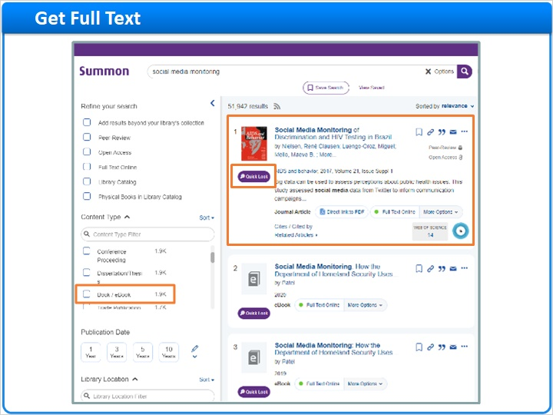
Notes:
Now let’s take a closer look at the results themselves.

This result is a journal article that is available online. I can click Quick Look to read more about it. If I want to read an article, I simply click on the article title to be taken to full text. If Summon has an Index-Enhanced Direct Link for this resource, Summon will take me directly to the article. If no Index-Enhanced Direct Link is available, Summon will route me through my full-text link resolver to get to the article.

This result is also a journal article, but only the citation is available online. The item is in my search results because my library subscribes to an Abstracting and Indexing database. In some cases, citation-only results will link to a library’s link resolver where there is information on requesting the item via interlibrary loan. My library has configured Summon to take me to the Abstracting and Indexing Details page. Here, I can read about the article, and click this button to request the item via interlibrary loan. I’ll click here to get back to my search results.

Now, I want to find a book, so I’ll choose Book / eBook from the Content Type facet. This result interests me. My library has a physical copy that may be available. I can click on the availability information here to go to my library’s catalog, and find out where in the library to get it. If the book were already checked out, that would also be noted in the availability information area. Fortunately, my library also has an electronic version of this book, so I could click here to read it online instead.

Full-Text Result (Slide Layer)
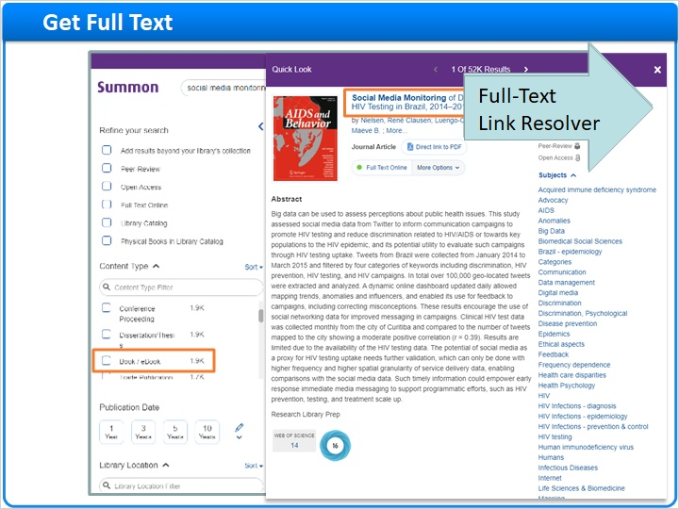

IEDL Full Text (Slide Layer)
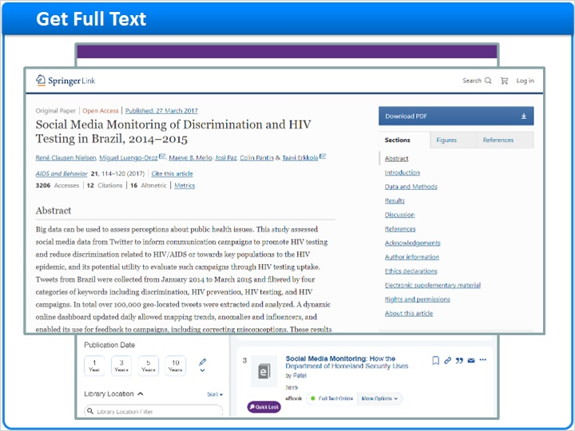

Link Resolver (Slide Layer)
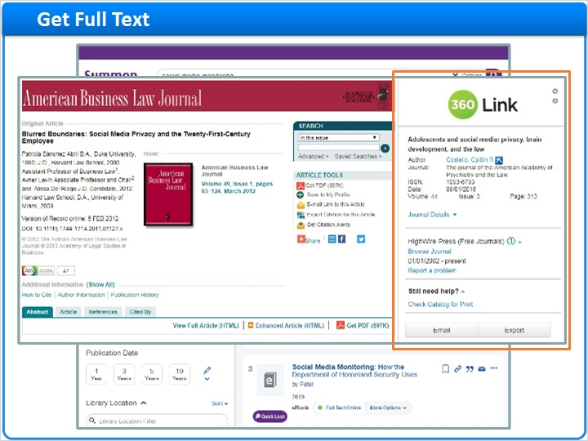

Citation Result (Slide Layer)
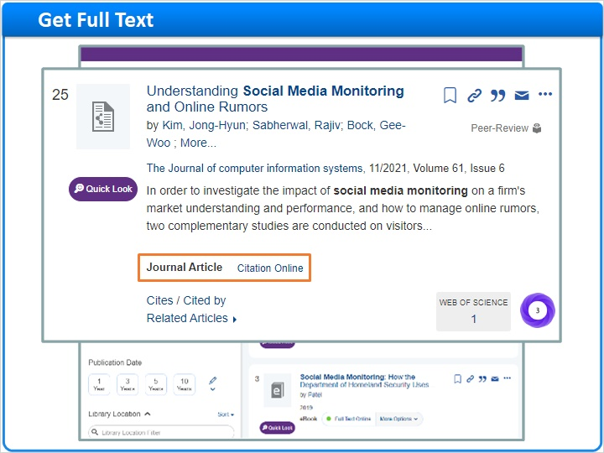

A&I Details Page (Slide Layer)
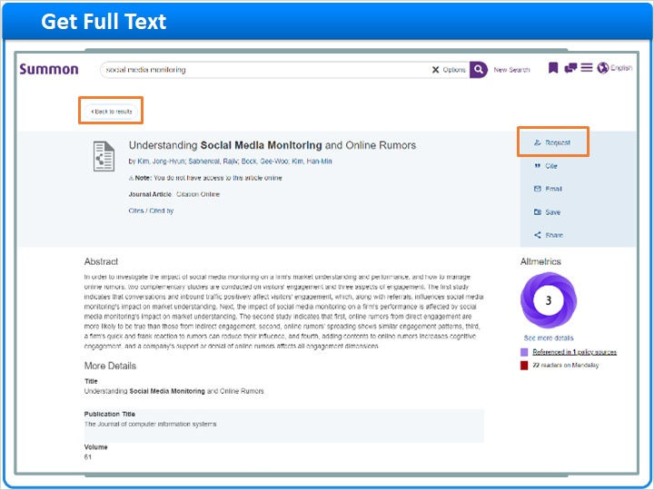

Book Result (Slide Layer)
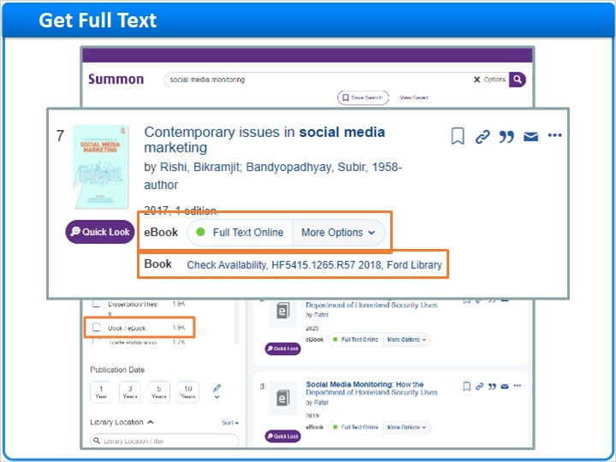

1.11 Expand Results
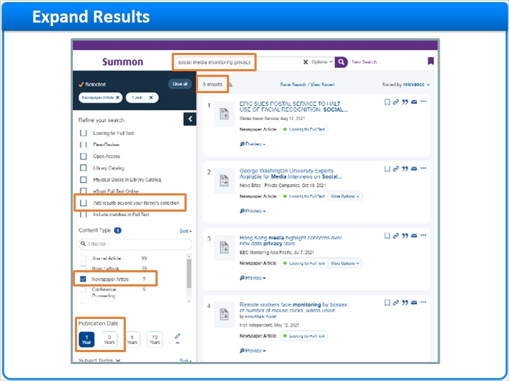
Notes:
We’ve looked at ways to use refinements and facets to filter down a large set of search results. But, what do I do if I want to expand my search results?

In this example, I’ve narrowed my search with more keywords. And, I only want to see newspaper articles published over a short time-period.

My search yielded just a few results, but I wonder if there are more out there? So I check the box, “Add results beyond your library's collection,” to see additional results from the Central Discovery Index.

Now I have more results. The ones in my library’s collection are available online. The ones outside my library’s collection appear as Citation Online, just like my library’s Abstracting and Indexing content. If any of these look interesting, I can click on their titles to learn how to request them via interlibrary loan.

Add Results Beyond Collection (Slide Layer)
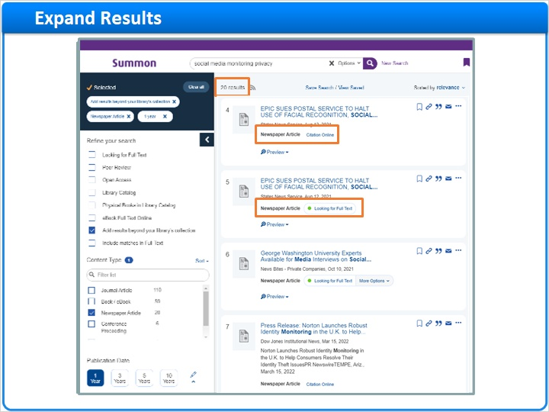

ILL Request Page (Slide Layer)
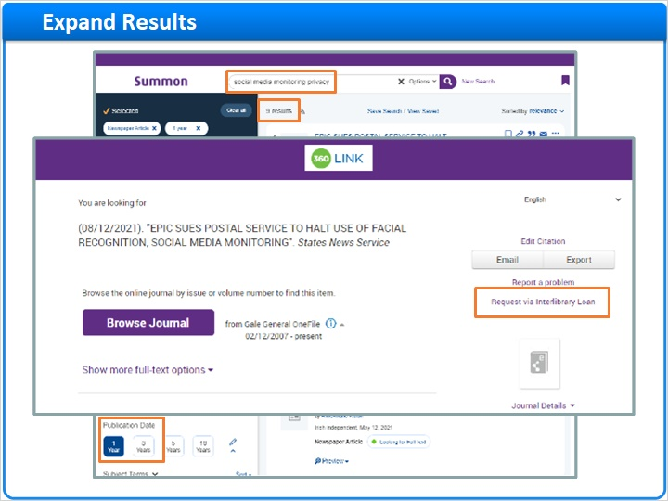

1.12 Save Citations
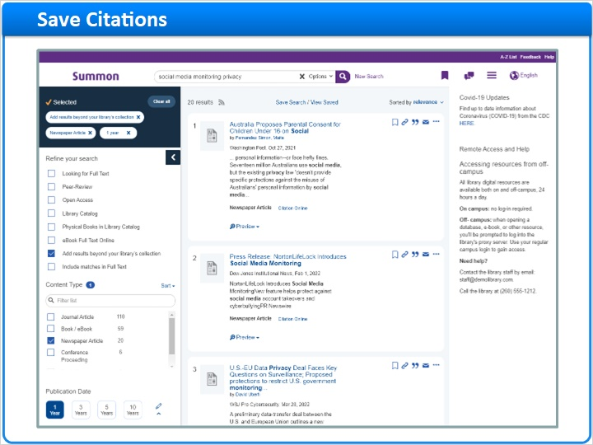
Notes:
Now that we’ve spent some time reviewing our search results, perhaps we would like to save some of these citations so that we can reference them later, email them to a friend or colleague, or even print them out.

When I click the icon here called Permanent Link, I’ll see a URL that will take me or any other researcher to a Summon search that has this exact citation as its only result item. It won’t go to the full text on the provider’s site, but just to this citation result in Summon.

To save citations, I click the banner icon to the right of each search result I want to save. The icon's color changes to show that the item has been saved to my temporary Saved-Items folder at the top of the page.

I can now go to the Saved Items folder and see my saved citations. I can choose a citation format and then print or email these citations. I can even export these citations directly out to various citation managers using this drop-down. If I don’t do anything with these Saved Items, they will disappear when I close my browser, or if I don’t use Summon for a period of time.

Zoom Upper Right of Page (Slide Layer)
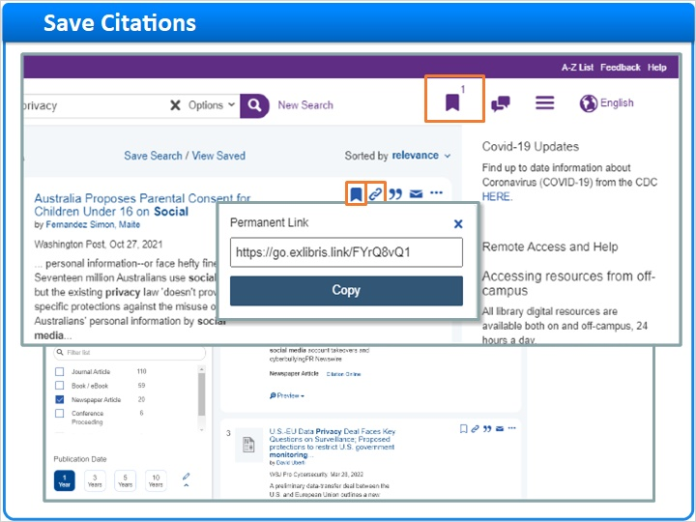

Saved Items Page (Slide Layer)
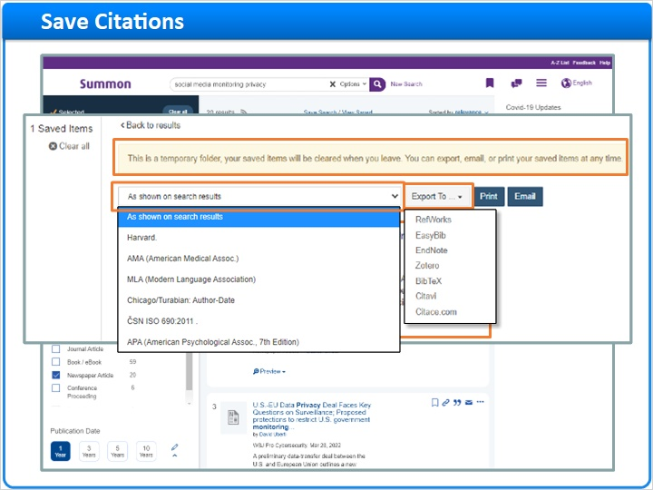

1.13 Save Searches
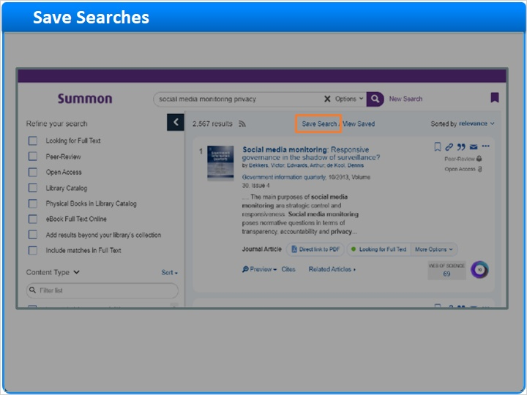
Notes:
We can also save the search query, so that it can be run again later.

I click Save Search, and a pop-up appears. I can save this search temporarily by just giving the search a distinctive name and then clicking Done.

However, when I’m done with Summon and I close my browser, my saved searches will be deleted. So, if I want to save searches permanently, I need to sign in with Google Drive or Microsoft One-Drive. If you don’t have one of those accounts, you’ll need to create it first.

After I sign in to my account, the pop-up changes to show which account will be used to save my Summon searches.

For the name of this search, I’m going to keep the search terms, but I’m going to add my refinements, too.

I click Done, and I’m back at my search-results page.

However, notice that the View Saved link at the top has a small number 1 next to it. That means I saved one search. I click that link, and the Saved Searches page appears. My saved search has the name I gave it, plus the search terms that were used, and that I filtered by publication-date range and content type. I can click on either the saved-search name or the search terms, and Summon will perform my search again, with those terms and filters.

I could also rename or even delete the saved search.

By the way, if you’re on a public computer, be sure to Sign out from your Google or Microsoft account before you leave, for security reasons.

Search save popup (Slide Layer)
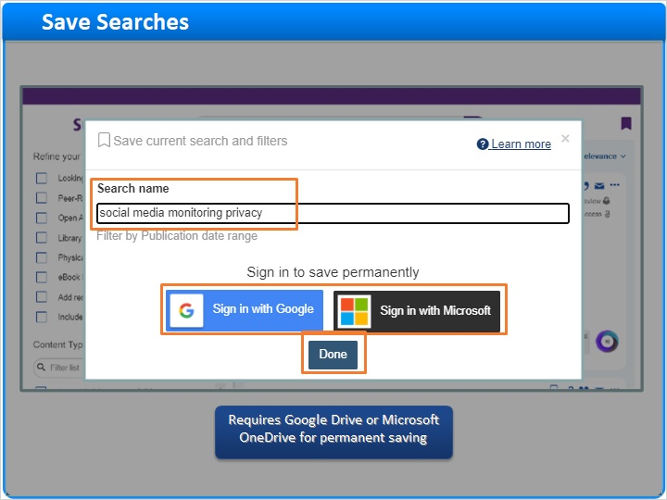

Search save popup after login (Slide Layer)
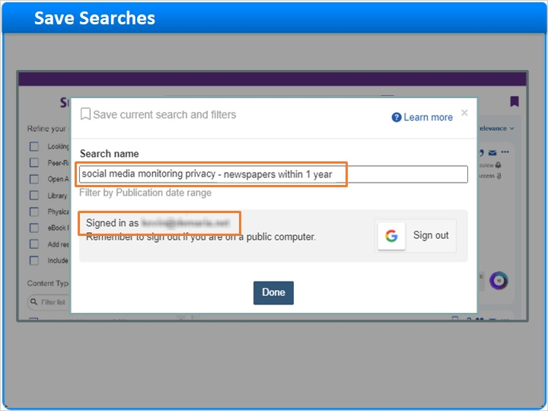

Results page with Saved Search (Slide Layer)
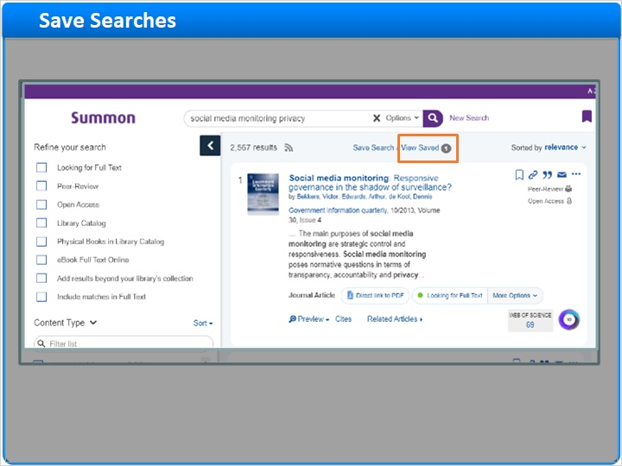

Saved Searches (Slide Layer)
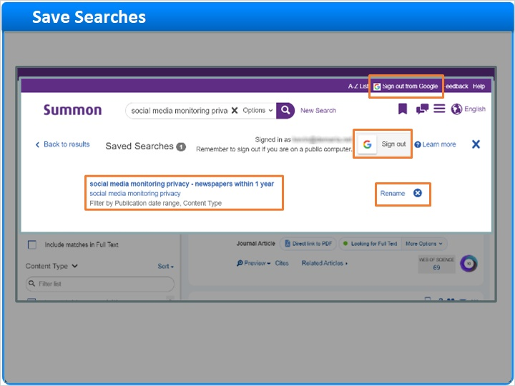

1.14 More to Summon
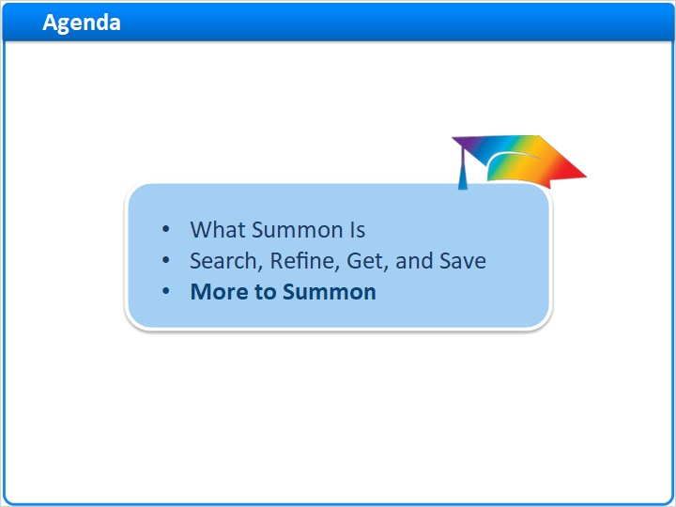
Notes:
There are a few more things to mention about the Summon interface.

1.15 Responsive Design
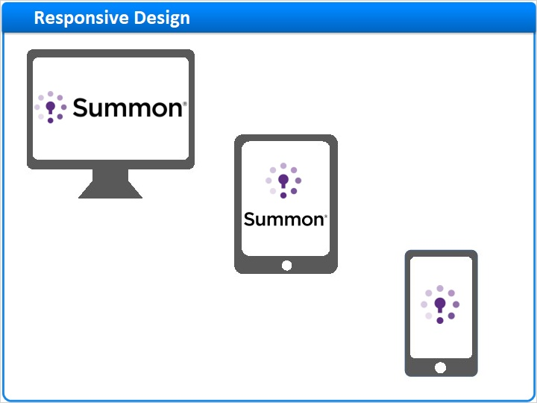
Notes:
So far, we’ve been looking at Summon on a desktop monitor, but Summon uses a technology called “responsive design,” so it looks great on tablets and smart phones, too.

Here’s an example of a search on a desktop monitor. There’s plenty of space for the facet pane on the left. There’s also room for the Topic-Explorer pane on the right, which we’ll discuss further in another session.

Now let’s look at the same search on a tablet. The Topic Explorer has moved under the results area.

And, here’s what the same search looks like on a smart phone. But this time, the refinements and facets are tucked away, behind this Filters link.

desktop (Slide Layer)
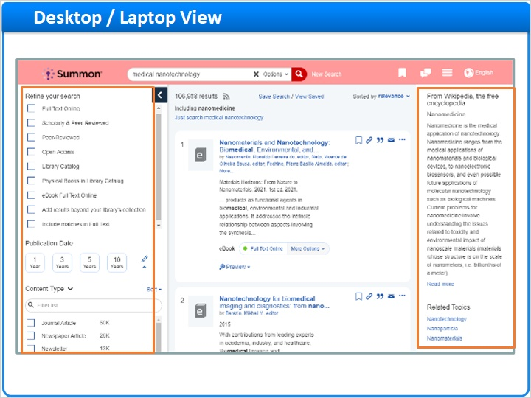

tablet (Slide Layer)
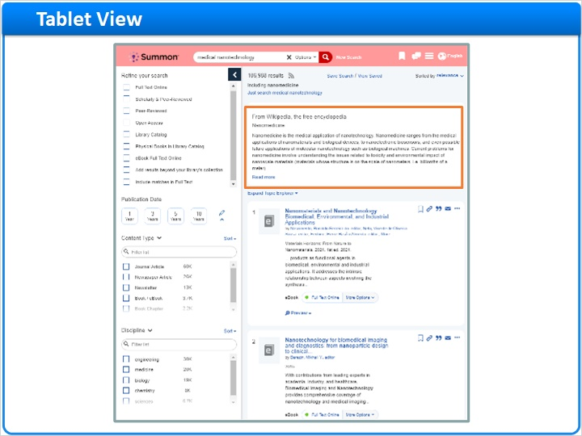

smart phone (Slide Layer)
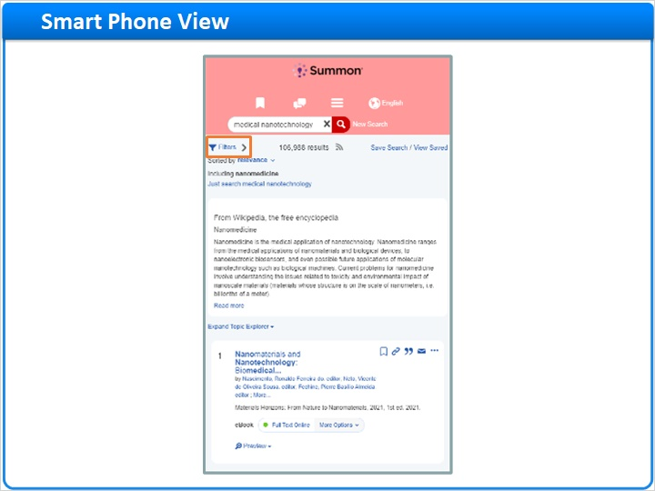

1.16 Much More to Summon
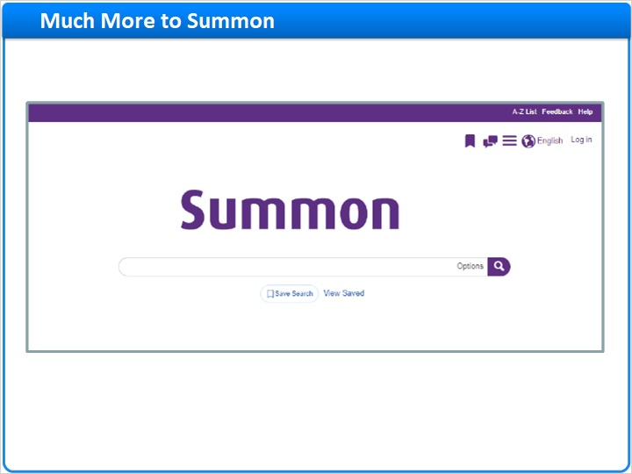
Notes:
There is much more to learn about using Summon, for example: Powerful Advanced-Search tools; A Topic Explorer pane featuring library reference materials, research guides, and messages from the library staff; Customizable Best Bets and Database Recommendations; Scholarly Impact Measures such as integrated citations counts from Web of Science and Scopus, and free Altmetric data for all libraries.

These features and more will be covered in other Summon training sessions.

Advanced Search Tools (Slide Layer)
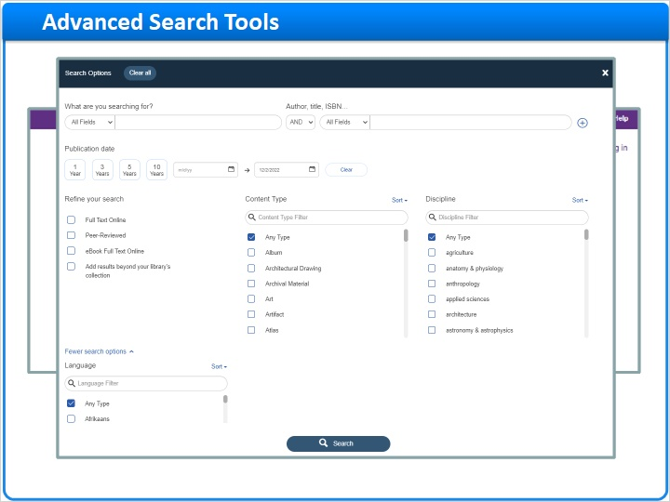

Topic Explorer (Slide Layer)
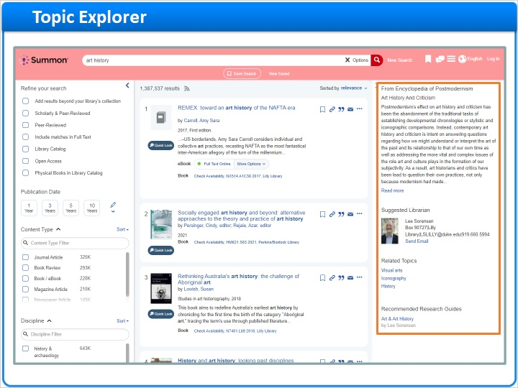

Recommendations (Slide Layer)
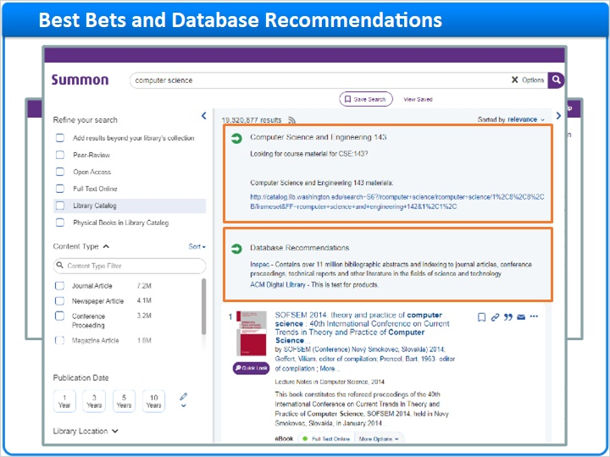

Scholarly Impact (Slide Layer)
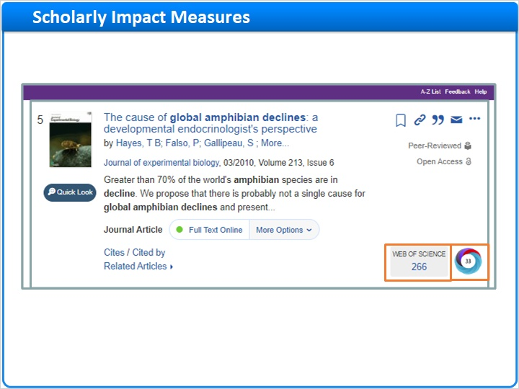

Wrap up (Slide Layer)
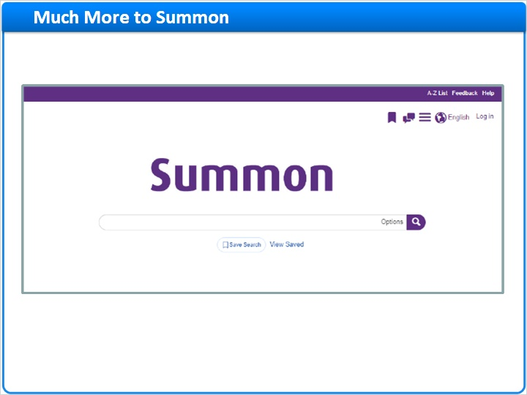

1.17 Session Review
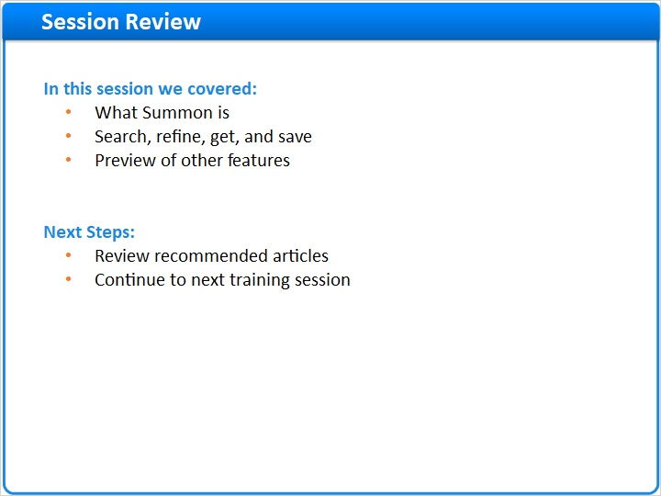
Notes:
This concludes the Introduction to Summon training session.

In this session, we explored what Summon is. We also learned the basic steps for searching in Summon, refining our results, getting full-text, and saving citations and searches. And we previewed some other features that will be discussed in other Summon training sessions.

What are your next steps?
· First, read the Recommended Articles for this session.
· Then, continue with your next training session.

1.18 Thank You!

Notes:
Thank you for joining us!

1.19 About this Training
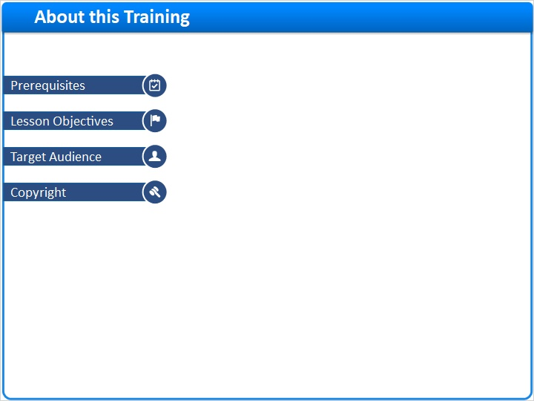
Notes:

1 (Slide Layer)
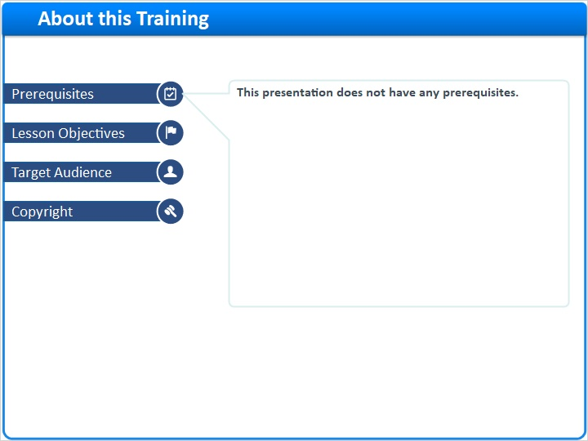

2 (Slide Layer)
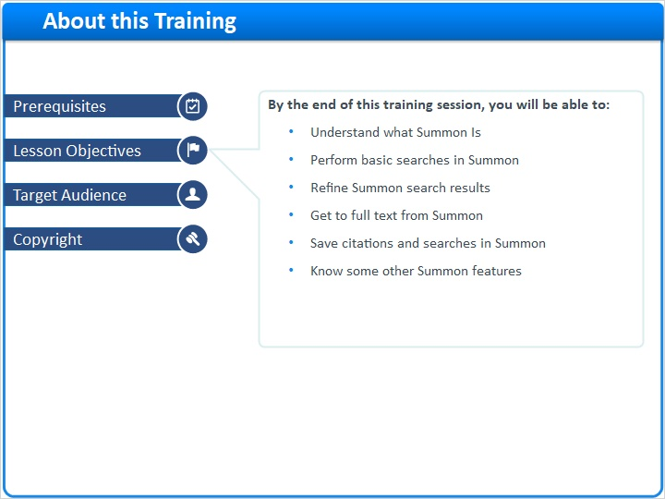

3 (Slide Layer)
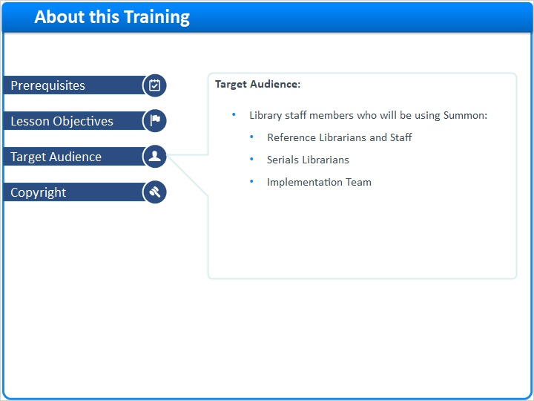

4 (Slide Layer)


